**WEEK-3**

**SPRING CORE AND MAVEN**

**MANDATORY**

1) **Configuring a Basic Spring Application**

Src/main/java

LibraryApp.java

**package** com.library.main;

**import** org.springframework.context.ApplicationContext;

**import** org.springframework.context.support.ClassPathXmlApplicationContext;

**import** com.library.service.BookService;

**public** **class** LibraryApp {

**public** **static** **void** main(String[] args) {

ApplicationContext context = **new** ClassPathXmlApplicationContext("applicationContext.xml");

BookService bookService = (BookService) context.getBean("bookService");

bookService.displayBook();

}

}

BookRepository.java

**package** com.library.repository;

**public** **class** BookRepository {

**public** String getBook() {

**return** "The Alchemist by Paulo Coelho";

}

}

BookService.java

**package** com.library.service;

**import** com.library.repository.BookRepository;

**public** **class** BookService {

**private** BookRepository bookRepository;

// Setter (used by Spring for injection)

**public** **void** setBookRepository(BookRepository bookRepository) {

**this**.bookRepository = bookRepository;

}

**public** **void** displayBook() {

System.***out***.println("Book: " + bookRepository.getBook());

}

}

Src/main/resources

applicationContext.xml

<?xml version="1.0" encoding="UTF-8"?>

<beans xmlns="http://www.springframework.org/schema/beans"

xmlns:xsi="http://www.w3.org/2001/XMLSchema-instance"

xsi:schemaLocation="

http://www.springframework.org/schema/beans

https://www.springframework.org/schema/beans/spring-beans.xsd">

<bean id="bookRepository" class="com.library.repository.BookRepository"/>

<bean id="bookService" class="com.library.service.BookService">

<property name="bookRepository" ref="bookRepository"/>

</bean>

</beans>

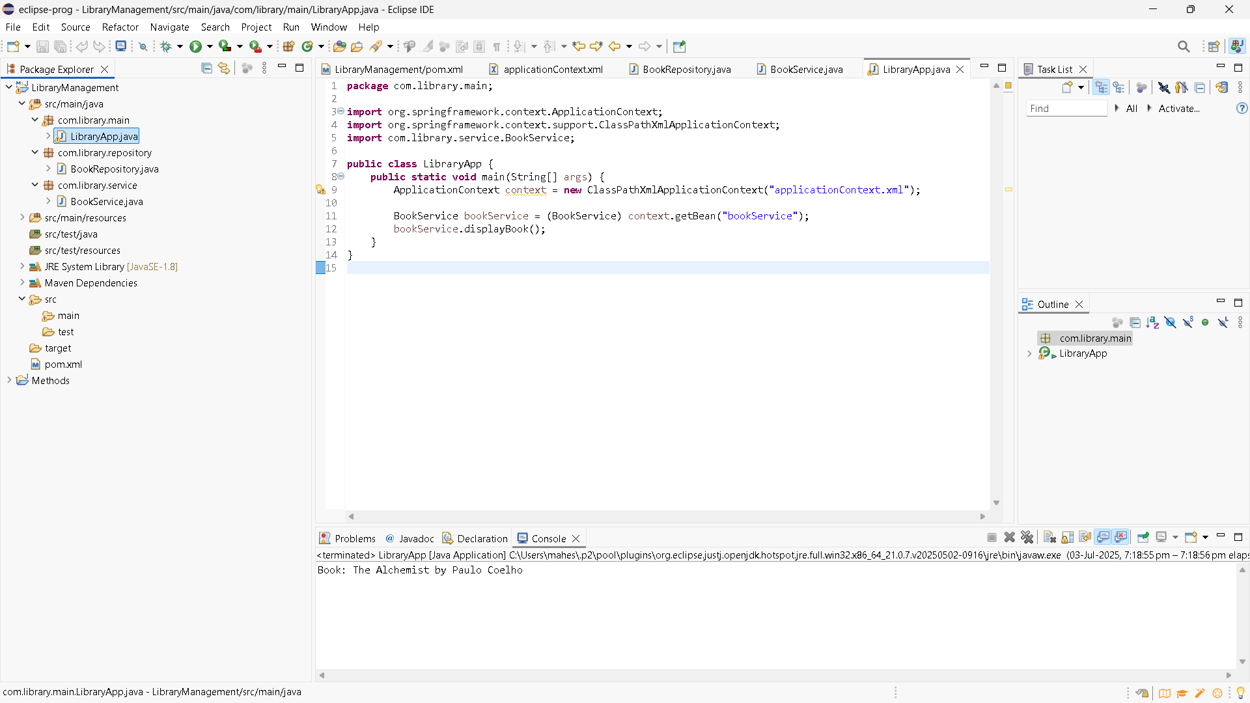

2) **Implementing Dependency Injection**

applicationContext.xml

<?xml version="1.0" encoding="UTF-8"?>

<beans xmlns="http://www.springframework.org/schema/beans"

xmlns:xsi="http://www.w3.org/2001/XMLSchema-instance"

xsi:schemaLocation="

http://www.springframework.org/schema/beans

https://www.springframework.org/schema/beans/spring-beans.xsd">

<!-- Define BookRepository bean -->

<bean id="bookRepository" class="com.library.repository.BookRepository" />

<!-- Define BookService bean and inject BookRepository using setter -->

<bean id="bookService" class="com.library.service.BookService">

<property name="bookRepository" ref="bookRepository" />

</bean>

</beans>

BookService.java

package com.library.service;

import com.library.repository.BookRepository;

public class BookService {

private BookRepository bookRepository;

// Setter method for DI

public void setBookRepository(BookRepository bookRepository) {

this.bookRepository = bookRepository;

}

public void displayBook() {

System.out.println("Book: " + bookRepository.getBook());

}

}

LibraryApp.java

package com.library.service;

import com.library.repository.BookRepository;

public class BookService {

private BookRepository bookRepository;

// Setter method for DI

public void setBookRepository(BookRepository bookRepository) {

this.bookRepository = bookRepository;

}

public void displayBook() {

System.out.println("Book: " + bookRepository.getBook());

}

}

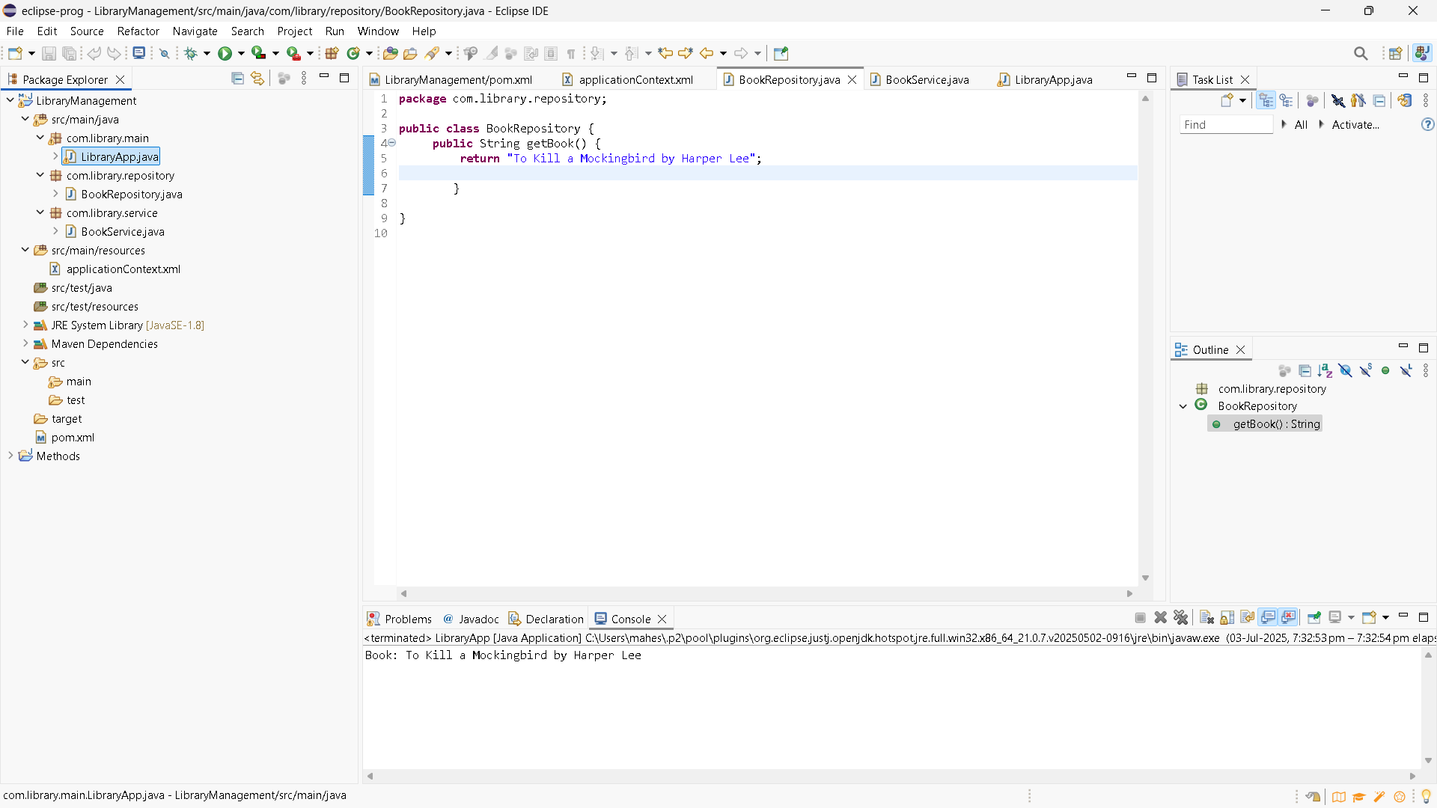

4) **Creating and Configuring a Maven Project**

pom.xml

<project xmlns="http://maven.apache.org/POM/4.0.0" xmlns:xsi="http://www.w3.org/2001/XMLSchema-instance" xsi:schemaLocation="http://maven.apache.org/POM/4.0.0 https://maven.apache.org/xsd/maven-4.0.0.xsd">

<modelVersion>4.0.0</modelVersion>

<groupId>com.library</groupId>

<artifactId>LibraryManagement</artifactId>

<version>0.0.1-SNAPSHOT</version>

<dependencies>

<!-- Spring Core -->

<dependency>

<groupId>org.springframework</groupId>

<artifactId>spring-context</artifactId>

<version>5.3.33</version>

</dependency>

<!-- Spring Context (Core Container) -->

<dependency>

<groupId>org.springframework</groupId>

<artifactId>spring-context</artifactId>

<version>5.3.34</version>

</dependency>

<!-- Spring AOP -->

<dependency>

<groupId>org.springframework</groupId>

<artifactId>spring-aop</artifactId>

<version>5.3.34</version>

</dependency>

<!-- Spring WebMVC -->

<dependency>

<groupId>org.springframework</groupId>

<artifactId>spring-webmvc</artifactId>

<version>5.3.34</version>

</dependency>

</dependencies>

<build>

<plugins>

<plugin>

<groupId>org.apache.maven.plugins</groupId>

<artifactId>maven-compiler-plugin</artifactId>

<version>3.11.0</version>

<configuration>

<source>1.8</source>

<target>1.8</target>

</configuration>

</plugin>

</plugins>

</build>

</project>

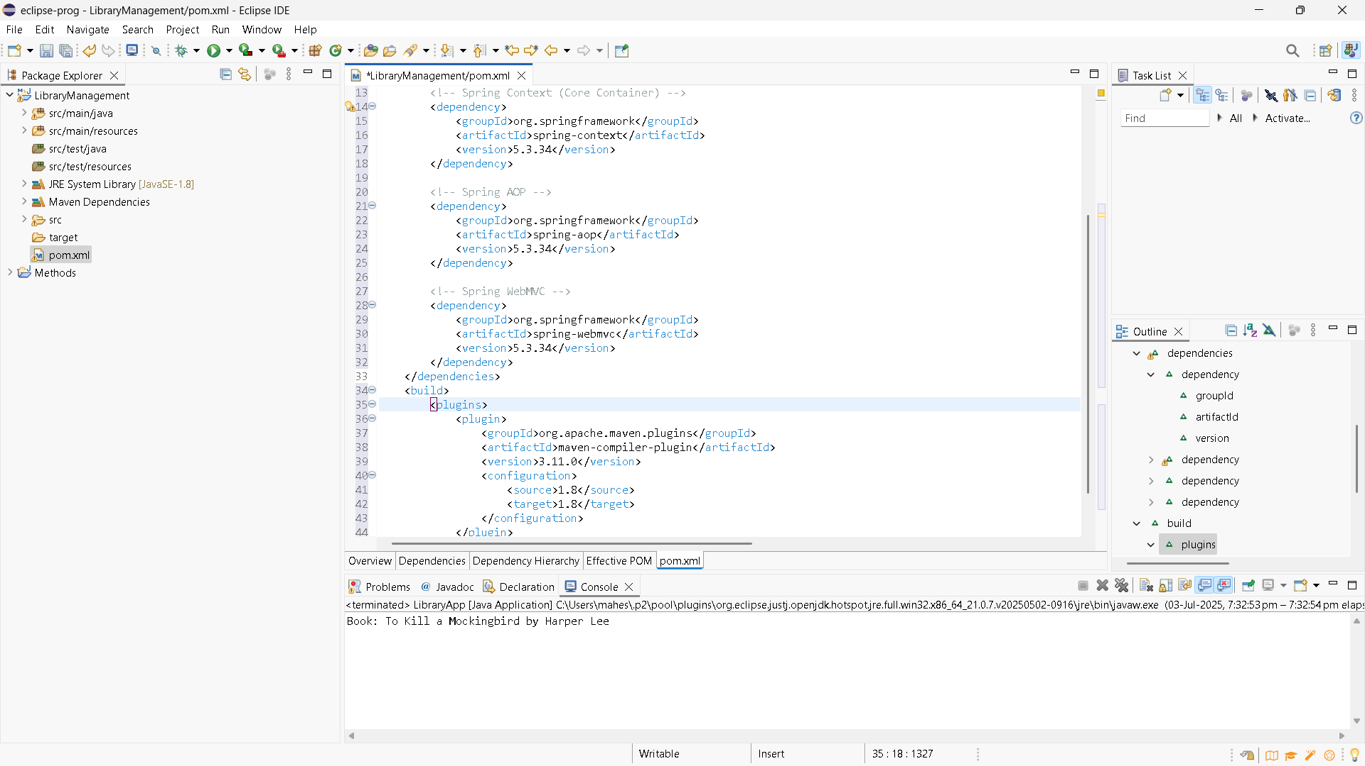

**Important Additional hands on**

5) **Configuring the Spring IoC Container**

ApplicationContext.xml

<?xml version="1.0" encoding="UTF-8"?>

<beans xmlns="http://www.springframework.org/schema/beans"

xmlns:xsi="http://www.w3.org/2001/XMLSchema-instance"

xsi:schemaLocation="

http://www.springframework.org/schema/beans

https://www.springframework.org/schema/beans/spring-beans.xsd">

<!-- Define the repository bean -->

<bean id="bookRepository" class="com.library.repository.BookRepository" />

<!-- Define the service bean and inject repository -->

<bean id="bookService" class="com.library.service.BookService">

<property name="bookRepository" ref="bookRepository"/>

</bean>

</beans>

BookService.java

package com.library.service;

import com.library.repository.BookRepository;

public class BookService {

private BookRepository bookRepository;

// Setter method for Dependency Injection

public void setBookRepository(BookRepository bookRepository) {

this.bookRepository = bookRepository;

}

public void displayBook() {

System.out.println("Book: " + bookRepository.getBook());

}

}

BookRepository.java

package com.library.repository;

public class BookRepository {

public String getBook() {

return "Sapiens by Yuval Noah Harari";

}

}

LibraryApp.java

package com.library.main;

import org.springframework.context.ApplicationContext;

import org.springframework.context.support.ClassPathXmlApplicationContext;

import com.library.service.BookService;

public class LibraryApp {

public static void main(String[] args) {

// Load Spring context from XML

ApplicationContext context = new ClassPathXmlApplicationContext("applicationContext.xml");

// Get BookService bean from context

BookService bookService = (BookService) context.getBean("bookService");

// Test the setup

bookService.displayBook();

}

}

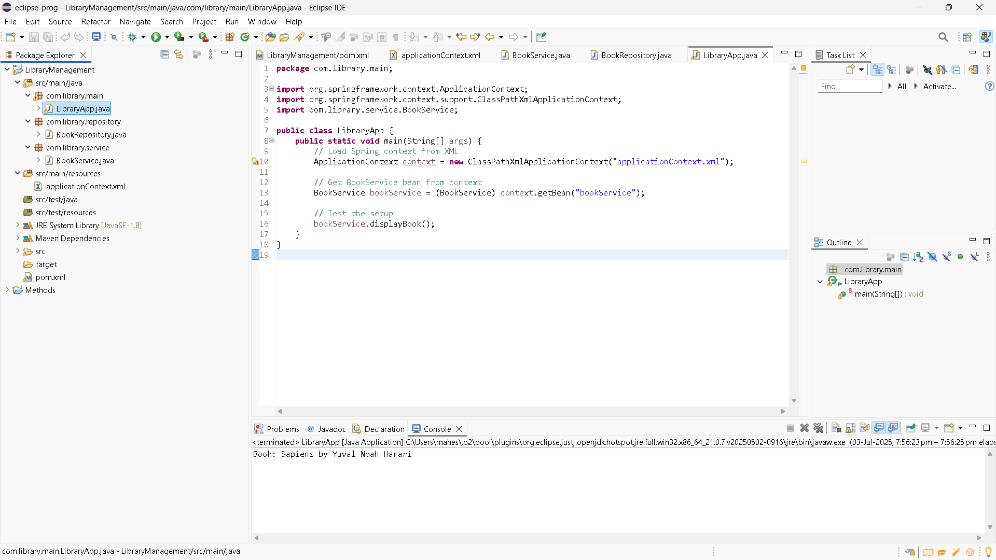

7) **Implementing Constructor and Setter Injection**

BookService.java

package com.library.service;

import com.library.repository.BookRepository;

public class BookService {

private String bookName; // constructor injected

private BookRepository bookRepository; // setter injected

// Constructor injection

public BookService(String bookName) {

this.bookName = bookName;

}

// Setter injection

public void setBookRepository(BookRepository bookRepository) {

this.bookRepository = bookRepository;

}

public void displayBook() {

System.out.println("Book Name: " + bookName);

System.out.println("Repository Says: " + bookRepository.getBook());

}

}

BookRepository.java

package com.library.repository;

public class BookRepository {

public String getBook() {

return "Available: Sapiens by Yuval Noah Harari";

}

}

applicationContext.xml

<?xml version="1.0" encoding="UTF-8"?>

<beans xmlns="http://www.springframework.org/schema/beans"

xmlns:xsi="http://www.w3.org/2001/XMLSchema-instance"

xsi:schemaLocation="

http://www.springframework.org/schema/beans

https://www.springframework.org/schema/beans/spring-beans.xsd">

<!-- BookRepository Bean -->

<bean id="bookRepository" class="com.library.repository.BookRepository" />

<!-- BookService Bean with Constructor and Setter Injection -->

<bean id="bookService" class="com.library.service.BookService">

<!-- Constructor Injection -->

<constructor-arg value="1984 by George Orwell" />

<!-- Setter Injection -->

<property name="bookRepository" ref="bookRepository" />

</bean>

</beans>

LibraryApp.java

package com.library.main;

import org.springframework.context.ApplicationContext;

import org.springframework.context.support.ClassPathXmlApplicationContext;

import com.library.service.BookService;

public class LibraryApp {

public static void main(String[] args) {

ApplicationContext context = new ClassPathXmlApplicationContext("applicationContext.xml");

BookService bookService = (BookService) context.getBean("bookService");

bookService.displayBook();

}

}

